CONNEC OpenAtlas Author Accreditation

Document created by Victoria Leonard, 30.06.2020
Feedback received from Becca Grose, Richard Flower and Alice Hicklin

Table of Contents:
1. Author and Contributor Accreditation
2. Database Accreditation
3. Other Considerations

Because there are now multiple authors contributing to CONNEC's OpenAtlas (Victoria Leonard, Becca Grose, Alice Hicklin, and David Natal), we need to sort out author accreditation.

Currently entries are stamped according to author and date of creation and modification. Whilst this is good, I think we could improve on the system. This is important, especially with the longer-term viability of the database in mind. Each researcher should be properly credited for their work, and they should be able to include it as part of their professional research profile.

1. Author and Contributor Accreditation

Individual Author Accreditation
The person who created and modified the entry should be named as the individual author for that entry. If no one else modified the entry, then no one else needs to be mentioned within the citation. This follows the example of the Cult of Saints database here:
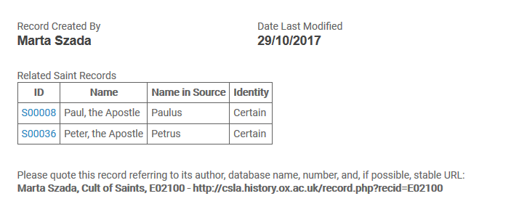
(http://csla.history.ox.ac.uk/record.php?recid=E02100)
The person who created the record is named, and the date the entry was last modified is included. We also want the ‘date last modified’ to be included, and to give the instruction for users to give a full citation with text that can be copied and pasted and a stable URL.

It would be useful to provide users with a Permalink that is easy to copy, such as the Prosopography of the Byzantine World does (highlighted in orange):
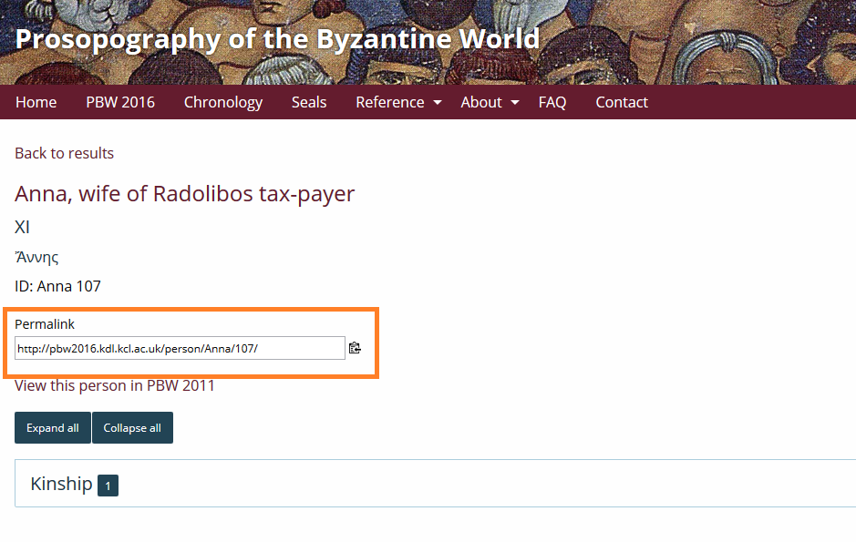
(https://pbw2016.kdl.kcl.ac.uk/person/106281/)
Or, more simply, we could just provide a Suggested Citation, as the Pleiades Database does:
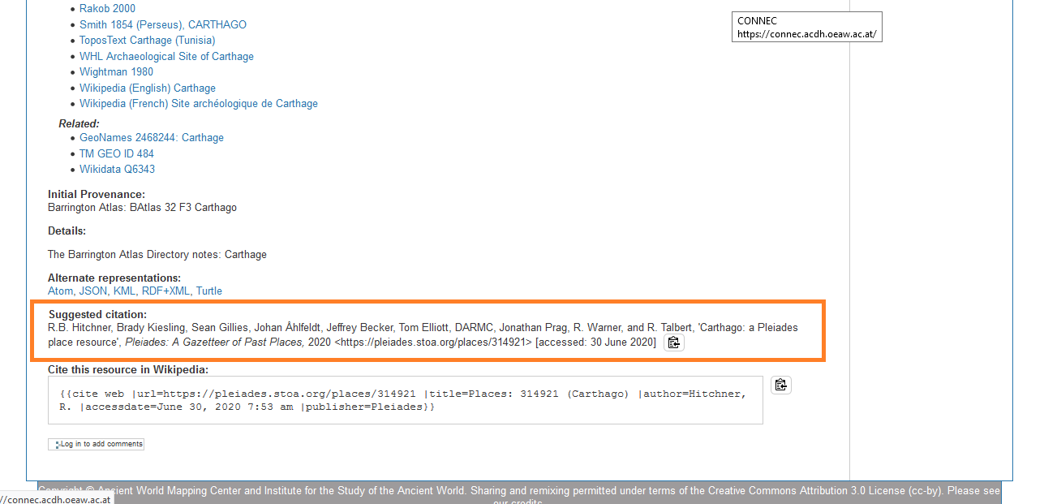
(https://pleiades.stoa.org/places/314921)

Multiple Contributor and Creator Accreditation
Where an entry has been created by one person and substantially modified by another person, the creator is still individually named, and a list of contributors follows, as demonstrated by the Pleiades database:
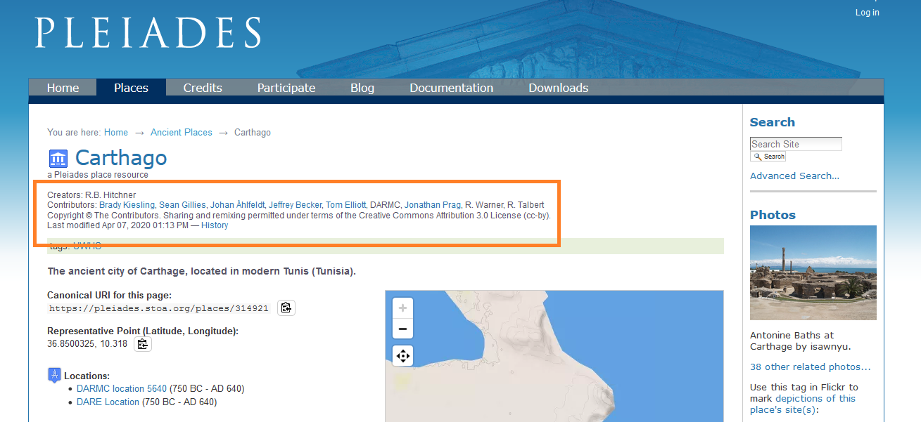
(https://pleiades.stoa.org/places/314921)
Because there will be relatively few entries in the database that have either been jointly created, or where one editor has created an entry that has then been so substantially changed as to require the editor to be named as an author, we would like to change the authorship from individual to multiple on a case-by-case basis. Where an entry has been created by Becca and Victoria has made small improvements to the entry, Victoria will not be named as an author/contributor for that entry. But the entry will show the date and person (ie. Victoria) who last modified the entry.
Any citation to an entry with multiple contributors would include the creator and any contributors as the authors, with the creator as the first author. So for example, if Becca created the entry for ‘Ianuarius’, and Alice and I then both substantially added to the entry, the citation would be:
Authors: Becca Grose, Alice Hicklin and Victoria Leonard
Ideally, as the image from Pleiades shows above, the names of the creator and contributors would be hyperlinked so that the user could click on a name and it would take them to a page showing a list of the all the entries that that user has created or contributed to:
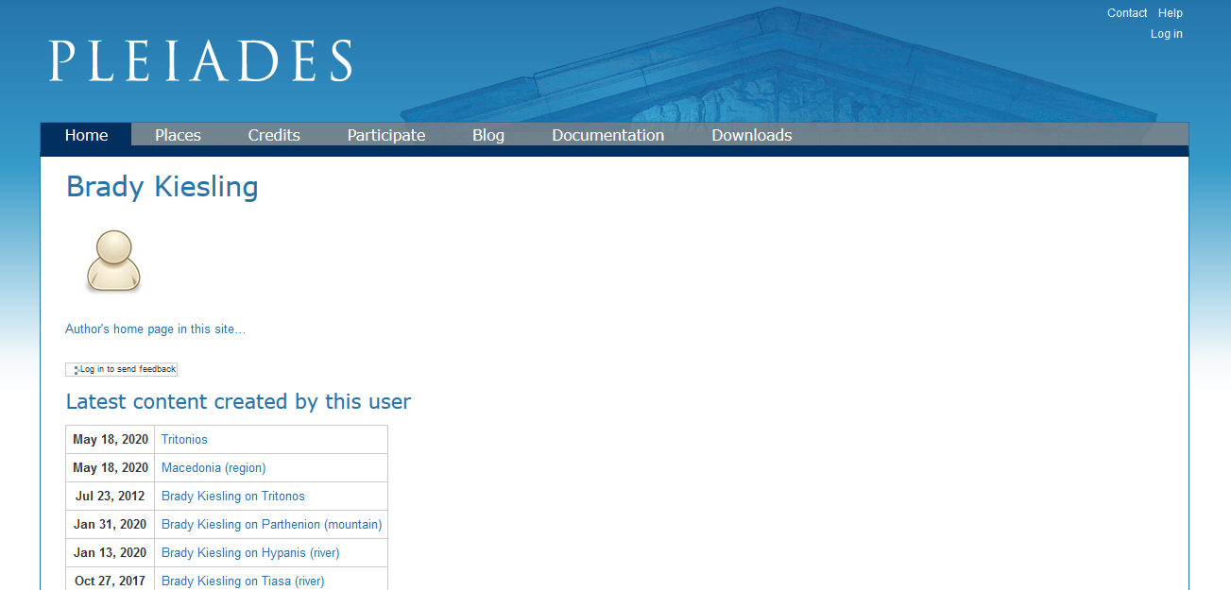
(https://pleiades.stoa.org/author/bkiesling)

2. Database Accreditation
The CONNEC OpenAtlas Database will have a front page for users to navigate from and containing information about the database. Although the full description of the database is yet to be decided on as the database is not yet complete, the page should include a full bibliographic description so that users can cite the database in bibliographies. This follows the example of the Prosopography of the Byzantine World (highlighted in orange):
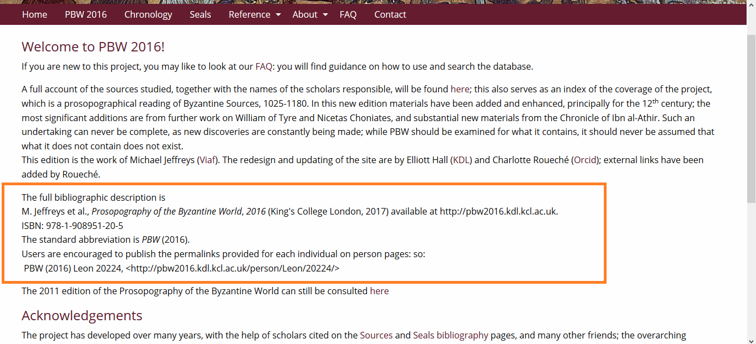
(https://pbw2016.kdl.kcl.ac.uk/)

For our database, this could read:
‘The full bibliographic description is
Victoria Leonard, Alice Hicklin, Becca Grose, and David Natal, Title of the Database? (Royal Holloway, University of London and the Austrian Centre for Digital Humanities, Austrian Academy of Sciences, 2021), available at … ’
When the database is complete we can to create an ISBN so that the database can be included in library catalogues.

There would also need to be accreditation for the software designers, creators and maintainers, and anyone else who has contributed to or whose work has been used in the creation of this database.
We should include, perhaps on a subpage, a description from Alice and I about our methodologies and database design, and from Becca about how she employed and managed an existing methodology in her inputting.

3. Other Considerations
When you access the database, a pop-up message could appear, saying that:

"By accessing the site, you must agree that you will use it for scholarly and personal use only, not for commercial gain."

The user then has to click 'I agree' before they can proceed into the database. This follows the Cult of Saints database:
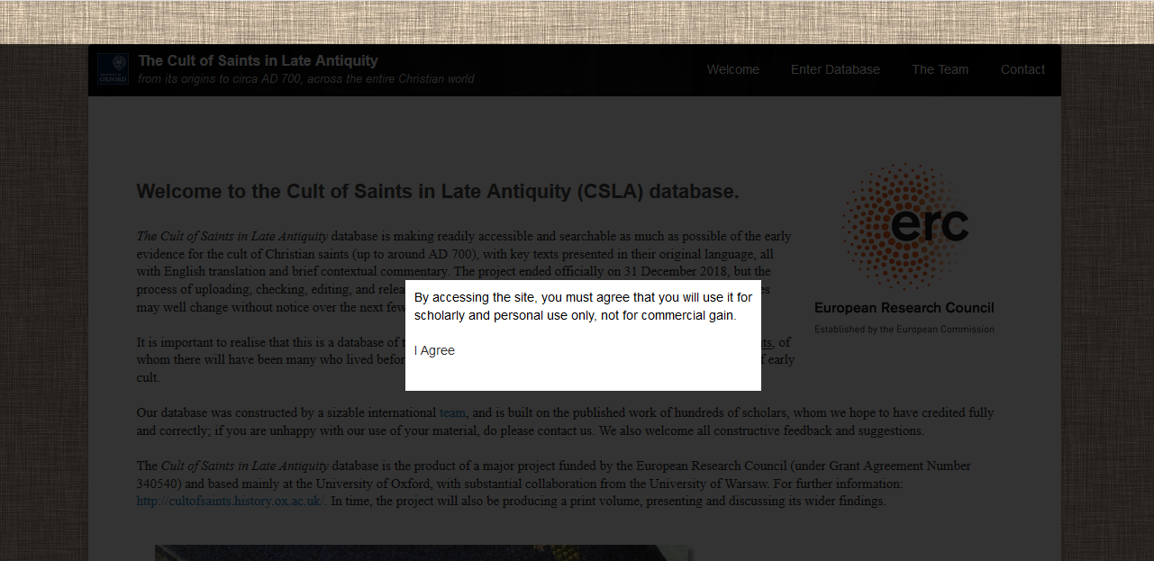

It would also be desirable to have a form embedded on the website for users to give feedback, called 'Additions and Corrections', like the Cult of the Saints database has:
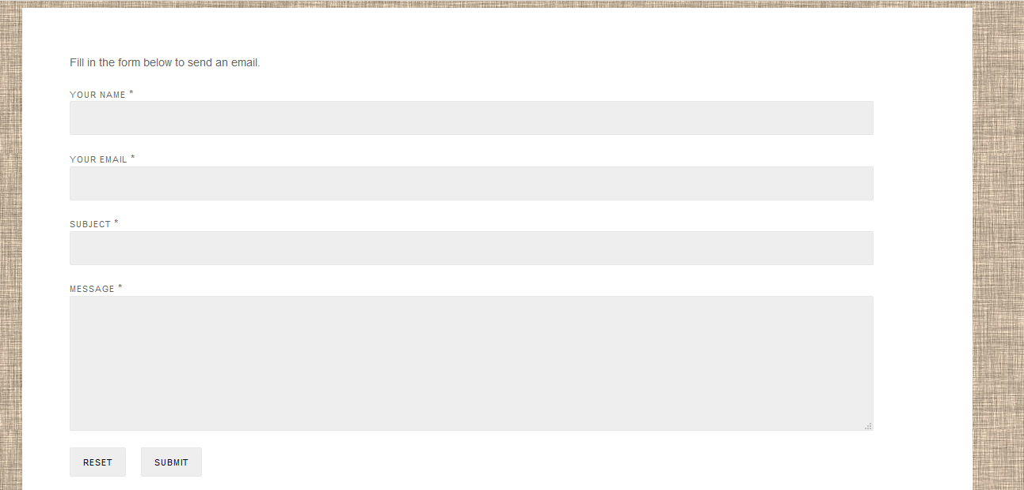(http://csla.history.ox.ac.uk/contact.php)

