List of proposed changes to be requested from Vienna.
We sincerely appreciate all of the time and support that you have given us with this website, and especially for your generosity in dealing with the delays on both sides but especially those on ours.
We have compiled this final list of proposed changes on the base of a test user event and accept that not all of these changes may be possible to implement in the timeframe left, and that any that do are also thanks to your generosity.
To acknowledge this, we have tried to signal the biggest changes that we would need to make the database usable and of wide interest with the following signals:
Asterisk and red (*) denote priority requests.

Accessibility requests

These requests emerged at our test user event, and to be compliant with university policy we’d be really grateful if they could be implemented.
- Could the default font size on all pages at regular zoom size be pt. 12 please? If they already are at pt 12, could this be increased by 2 pts?

- Some of the maps are currently not usable by people with visual impairments due to the colour choice. We wondered if it might be possible to either:
- implement a new pal ette e.g. [This website (http://pallett.es) can generate palettes based on a chosen starter color or random: e.g. https://palett.es/00576a-0092a2-f2ffd5-e1f2bb-d06d00e]
- allow users to change the colour attributed to each case study on the map

Home Page
(i.e. https://discover-connec.openatlas.eu/)

1. Top search bar:
- Add ability to filter search results by ‘Case Study’ (Custom type). (N..B. this might need to be implemented on the results page instead - we would like the case study to be displayed on the results page as a field alongside existing sortable fields
- Add ability to search for a term/string of words across all categories (i.e. not to search only in sources or artifacts or events)*
- Add an explanation of how the search works (no wildcards, no Boolean operators etc.)
We’ve provided an example below, but we would be grateful if you could provide the exact text, as you know from the code exactly what it does/does not do. Suggestion: maybe this could appear in grey above/below the search settings in the dropdown display. 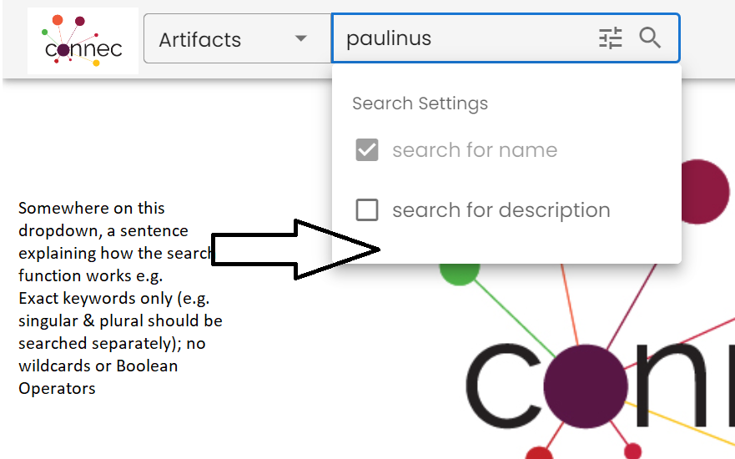

2. Logo and section links
In addition to the general accessibility requests, could the section links (e.g. User Guide; Map; Actor Connections) displayed next to the logo be made 2 pts bigger than any other text on screen, aside from the logo? Currently, test users are failing to realise that this is the most important information on screen. (Image below for clarity)
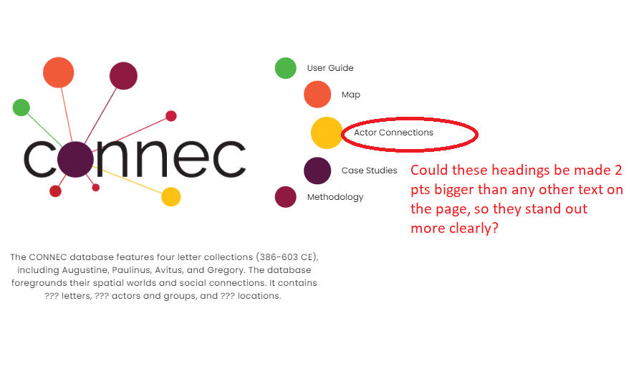

3. Map

- Add a button that resets the map to default view
- Ideal but optional: Add the ability to download the map visible on screen as an image file. (or to select an area of the current view to download). Downloaded image file to include image, link to website, and copyright details (e.g. via watermark or within the image description.)

- Optional/low priority: Could the region outlines (currently demarcated in blue) be made paler and/or removed when the map doesn’t display an event that involves this location.
- (See accessibility comments above about colour scheme.)

People page & Event page + Addition of Source pages (priority)**
(e.g. https://discover-connec.openatlas.eu/single/846 (people); https://discover-connec.openatlas.eu/single/5146 event; Connected Clerics in Late Antiquity (openatlas.eu) source )

Add link from event and people pages to the source pages that attest to their existence

We are aware that this is a big ask , but test users said that the methodology behind our website (and CIDOC-CRM more generally) does not make sense if there is no clear way to access the source pages from event and people pages.
- Would it be possible to add a clear link to ‘sources’ from event and people page e.g.
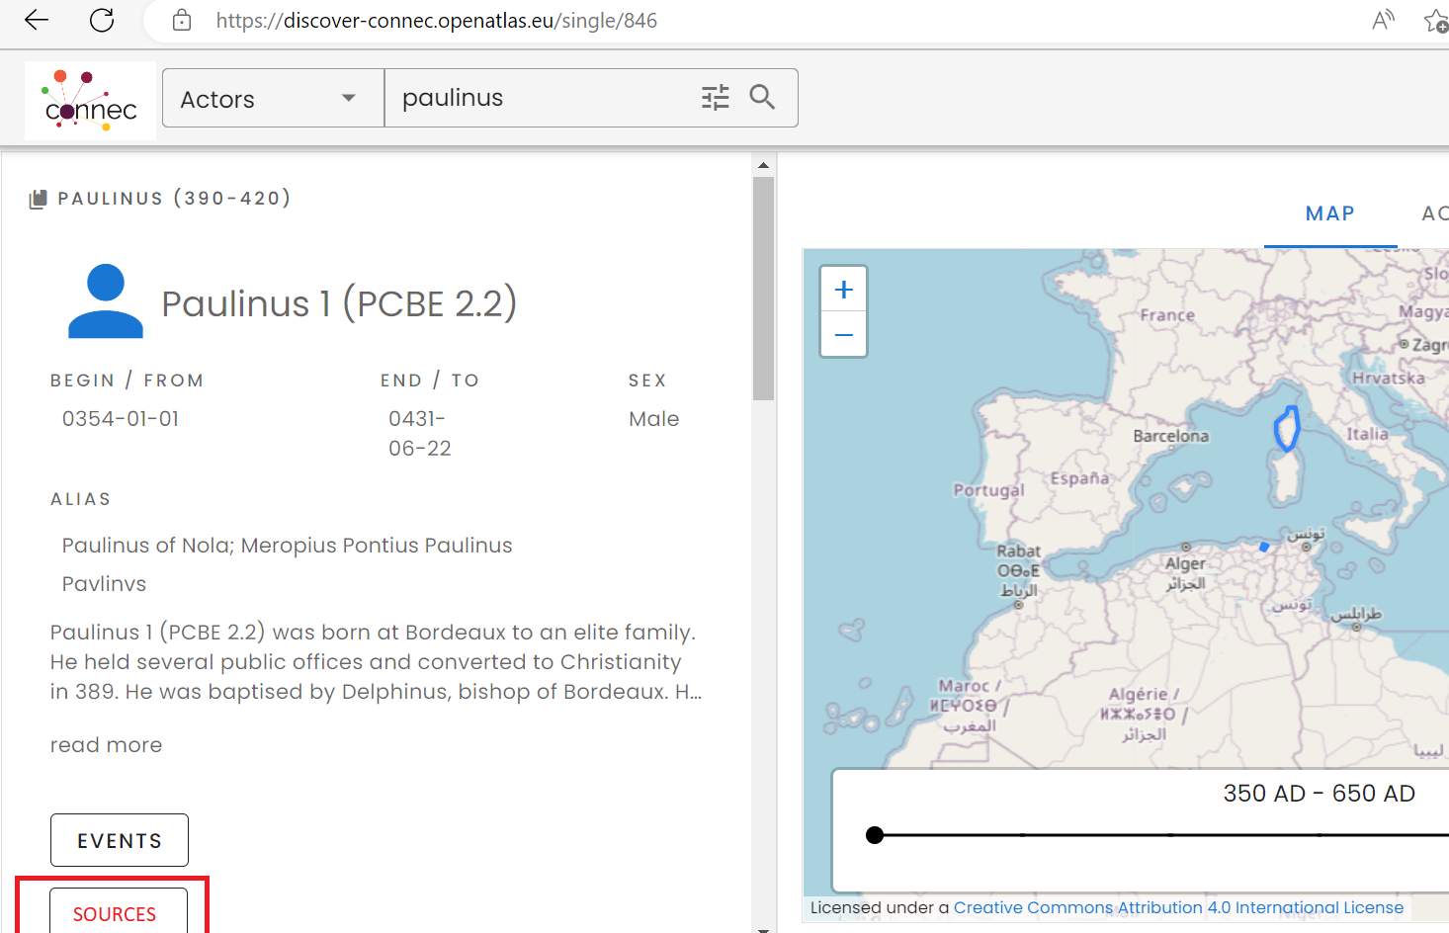

Navigation & previews

- Users couldn’t understand what these buttons do, e.g. how to navigate from person page to event page to source page. We suggest an explanation box next to the button on each page e.g.
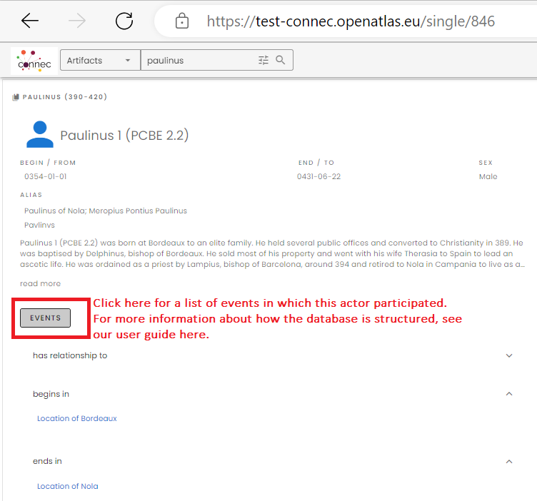

- More signposting is needed on the preview page to help people understand that it is a preview. We wondered if we could add explanatory text to each preview pane, e.g.
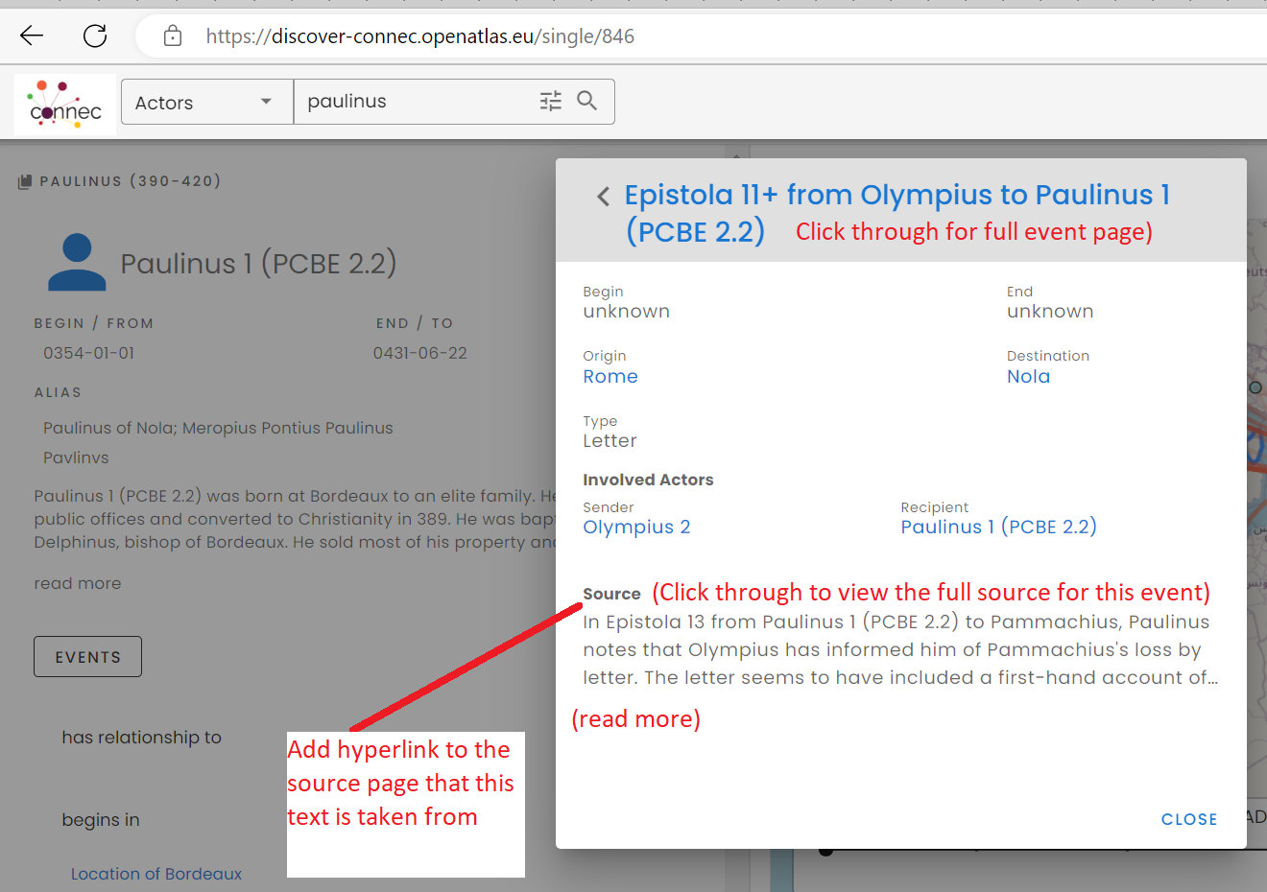

Titles: add type of page (artifact/event/person/source) to title

- Could the type of page (artifact/event/person/source) be displayed at the top of the page itself, to help users identify what sort of page they are on.

Map previews panes (person; event; source; artifact pages)
- Map previews are currently only correct on the event and person pages.
The source pages and artifact pages show a map of all events that occur in the database.
Could the artifact page map preview panes be updated to show only move events that involve that artifact (and/or removed)?
Could the source page map preview panes be updated or removed?

Visualise extra custom types
- Could the following custom types be displayed, where the entry includes text? [NB these are all currently blank, but they should show up like alternative names currently do.]
Biblical citations
Internal references
PCBE number
PLRE number

Case study pages
(e.g. Connected Clerics in Late Antiquity (openatlas.eu))
- Would it be possible for the case study pages to contain a list of all the sources that are listed in the case study, with hyperlinks to those pages?

Actor Network page

1. Actor network diagrams
- Low priority:Window to fit to the size of network displayed and be centered on visualized network.
- Low priority: distinct colour for nodes for each case study (hatched lines for individuals who appear in 2 case studies?)

Potential features to implement across all pages (source, event, people, artifact etc): low priority

- Only years to be displayed, not full dates. (If possible, opt in box available if anyone later wishes to add back the full date.)
- Could all maps be automatically resized to fit the items selected for display. E.g. there is often a lot of blank map space on the people page and on the main page.
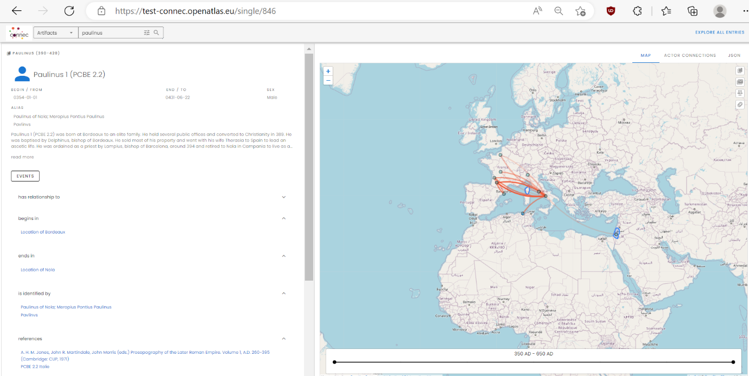

User Guide
i.e. Connected Clerics in Late Antiquity (openatlas.eu)
- Can the ‘User Guide’ page (display the content of the Custom Type ‘User Guide’ (CONNEC - Types (openatlas.eu))
- We need to send one set of extra information to be embedded next year, providing hyperlinks and video to guide users once the site is finalized. Is this okay?

